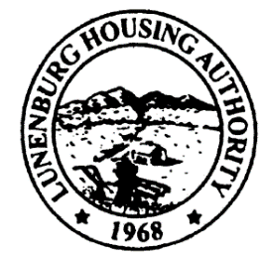
Town Clerk Received:
Lunenburg Housing Authority
C/O Leominster Housing Authority, Managing Agent
100 Main Street
Leominster, Massachusetts 01453-5599
Phone: (978) 537-5300 Fax: (978) 534-5335
North Central Mass Housing (ncmhousing.org)

NOTICE OF REGULAR MEETING
Submitted by: Benjamin Gold, Executive Director Date: 2/20/2024
Notice is hereby given in accordance with Section 23B of Chapter 39 of the General Laws that a regular meeting of the Lunenburg Housing Authority Board of Commissioners will be held at 2:00 P.M. on 2/29/2024, in the Community Room at 131 White Street, in the town of Lunenburg, Massachusetts.
The public is invited to call in to the meeting via phone. To do so, call the conference line at (888) 982-0015 and enter the code 186-282-336. The Chair will conduct the meeting and instruct the public on the appropriate time and manner for comments.

AGENDA
- Opportunity for Public Comments

- Meeting Called to Order
a. Roll Call
b. Approval of Regular Minutes – 1/18/2024

- Executive Director Report
a. Board Member Training
b. Ethics Training
c. Blank Lease
d. MassNAHRO Legislative Day 3/7/2024
e. Board Seat Term Ending in May

3. Financials
a. Approval of November and December, 2023

4. Administration
a. Modernization/Work Order Report
b. State-Aided Housing Report

5. Unfinished Business – None

6. New Business
- Resolution 2024-2 Year-End Financial and Federal-State Lead Paint Certifications
- Resolution 2024-3 FY2024 Budget

7. Other Correspondence
- EOHLC PHN 2024-2 Requirement to consult residents when entering into Management Agreements

8. Motion to Adjourn

