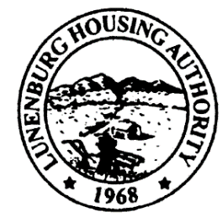
Town Clerk Received:12:21pm
6/5/24
EG
Lunenburg Housing Authority
C/O Leominster Housing Authority, Managing Agent
100 Main Street
Leominster, Massachusetts 01453-5599
Phone: (978) 537-5300 Fax: (978) 534-5335
North Central Mass Housing (ncmhousing.org)

NOTICE OF REGULAR MEETING
Submitted by: Benjamin Gold, Executive Director Date: 6/5/2024
Notice is hereby given in accordance with Section 23B of Chapter 39 of the General Laws that a regular meeting of the Lunenburg Housing Authority Board of Commissioners will be held at 2:00 P.M. on 6/13/2024, in the Community Room at 131 White Street, in the town of Lunenburg, Massachusetts.
The public is invited to call in to the meeting via phone. To do so, call the conference line at (888) 982-0015 and enter the code 255-438-612-351. The Chair will conduct the meeting and instruct the public on the appropriate time and manner for comments.

AGENDA
- Meeting Called to Order
a. Roll Call
b. Approval of Regular Minutes – 3/21/2024

- Executive Director Report
a. Board Member Training
b. Ethics Training
d. Ben to NERCNAHRO
e. PMR

3. Financials
a. Approval of April and May, 2024

4. Administration
a. Modernization/Work Order Report
b. State-Aided Housing Report

5. Unfinished Business – None

6. New Business
a. Resolution 2024-7 Federal Pacific Panel and Installation Project CSC

7. Other Correspondence
- EOHLC PHN 2024-6 Agreed Upon Procedures (AUP) Program: Pre-Qualified Certified Public Accounting (CPA) Firms
- EOHLC PHN 2024-7 Promulgation of Amendments to 760 CMR 6.00

8. Motion to Adjourn

