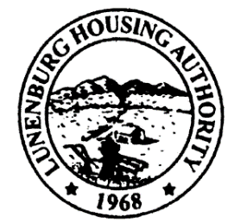
Town Clerk Received: 9/11/24
11:18am EG
Lunenburg Housing Authority
C/O Leominster Housing Authority, Managing Agent
100 Main Street
Leominster, Massachusetts 01453-5599
Phone: (978) 537-5300 Fax: (978) 534-5335
North Central Mass Housing (ncmhousing.org)

NOTICE OF REGULAR MEETING
Submitted by: Benjamin Gold, Executive Director Date: 9/11/2024
Notice is hereby given in accordance with Section 23B of Chapter 39 of the General Laws that a regular meeting of the Lunenburg Housing Authority Board of Commissioners will be held at 2:00 P.M. on 9/19/2024, in the Community Room at 131 White Street, in the town of Lunenburg, Massachusetts.
The public is invited to call in to the meeting via phone. To do so, call the conference line at (888) 982-0015 and enter the code 277-125-541-110. The Chair will conduct the meeting and instruct the public on the appropriate time and manner for comments.

AGENDA
- Meeting Called to Order
a. Roll Call
b. Approval of Regular Minutes – 8/15/2024

- Executive Director Report
a. Sea Crest, September 8-10
b. Management Agreement
c. Maintenance

3. Financials
a. Approval of August, 2024

4. Administration
a. Modernization/Work Order Report
b. State-Aided Housing Report

5. Unfinished Business – None

6. New Business
- Resolution 2024-10 Authorizing Signing Certificate of Substantial Completion Federal Pacific Panel and Intercom Replacement Project 162041

7. Other Correspondence
- EOHLC PHN 2024-13 Budget Guidelines
- EOHLC PHN 2024- 14 Demographic Reporting
- EOHLC PHN 2024-15 689/167 Contract Transition to DocuSign

8. Motion to Adjourn

